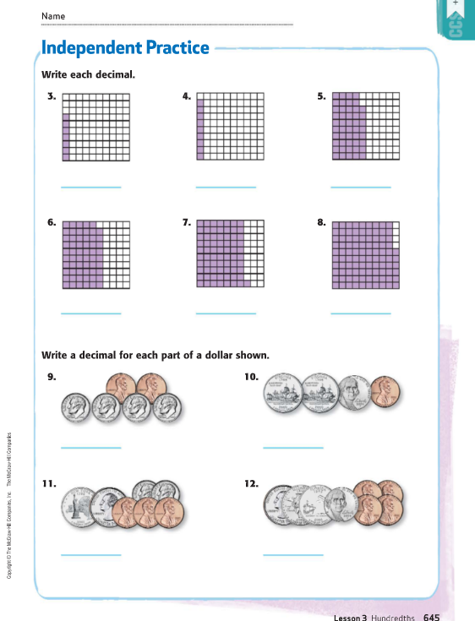 | 3) There are 100 little squares. That is like 100 pennies. So we write the fraction 7 we write decimals that are out of hundred squares .07  100  Ones place . tenths hundredths  . 0 7  4) 9 we write as 0.09 Ones place. tenths hundredths  100 0 . 0 9  5) 48 which is .48 Ones place. tenths hundredths  100 0 . 4 8  6) .59 forty nine hundredths  7) 0.71 seventy nine hundredths  8) 0.94  9) 0.42 10) 0.31 11) 0.73 12) 0.84
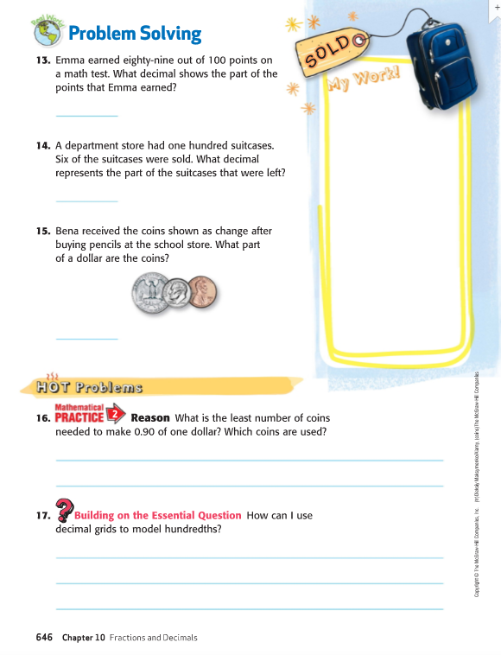 | 13) 89 0.89 14) They had 100 – 6 = 94 So the decimal is 0.94  100  15) 0.36  16)  .90 9 dimes  .90 6 dimes 1 quarter 1 nickel  .90 3 quarters 1 dime 1 nickel

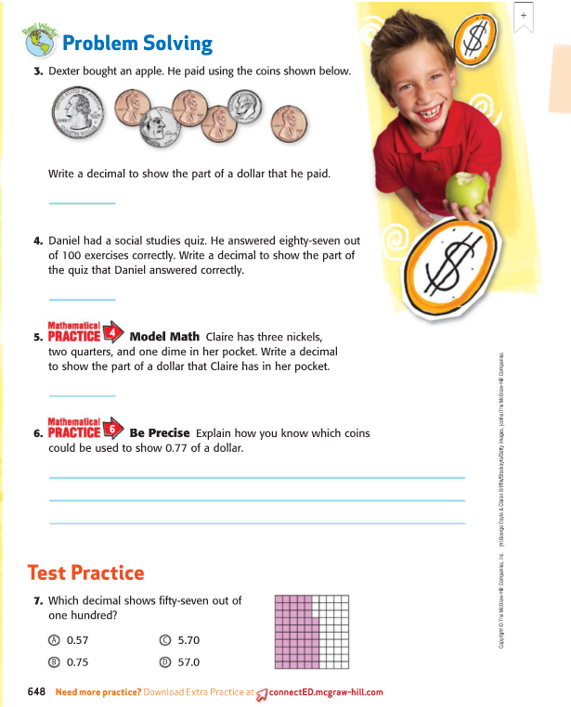 | 3) 0.44  4) 0.87  5) 3 nickels = 0.15  2 quarters = 0.50  1 dime = 0.10  The total amount is 0.75  6) If I know the value of each coin I can begin with the larger coin – quarter = 0.25  Well 2 quarters = 0.50 2 dimes = 0.20 1 nickel = 0.05 2 pennies 0.02  7) A

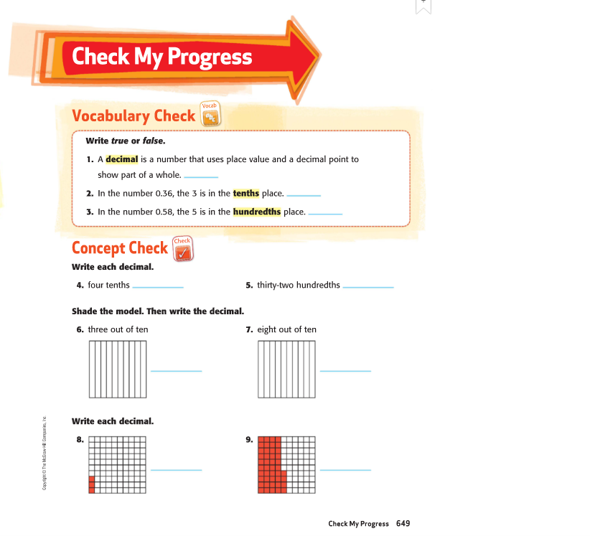 | - True  - True  - False  Ones . tenths hundredths  4) 0.4  5) 0.32  6 ) = .30  7) = .80

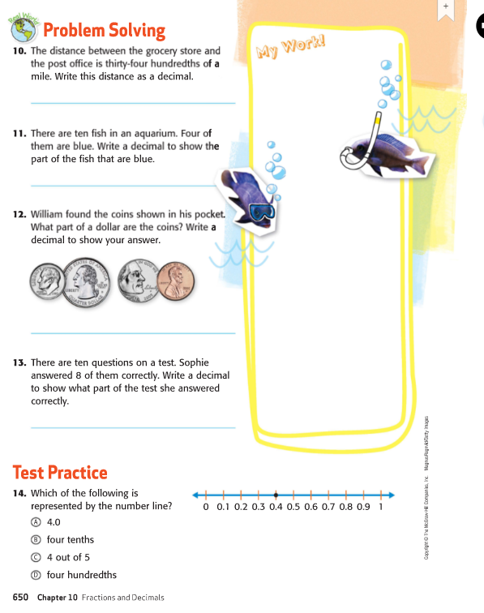 | 10) .34  11. 10 fish 4 are blue = .40 4 tenths is like 4 dimes = .40  10  12) 41 cents = .41 or 0.41  13) 8 out of 10 ( I think 8 dimes ) = .80  14 B four tenths. The number line is broken into 10 parts

