Hi Parents! Welcome to Week 1 of our digital learning days. It is recommended that 4th grade students spend at least 2 hours working through our plans each day.
I have divided up the time for each subject to fit into the 2 hour time required. However, the resources provided are all amazing, so if they want to continue their learning,
that is just fine! 😊

Monday | Tuesday | Wednesday | Thursday | Friday
Math:  Zearn: 20 minutes  Math Day 1 workbook pages: 20 minutes  631-636 | Math:  Zearn: 20 minutes  Math Day 2 workbook pages: 20 minutes  637-642 | Math:  Zearn: 20 minutes  Math Day 3 workbook pages: 20 minutes  643-650 | Math:  Zearn: 20 minutes  Math Day 4 workbook pages: 20 minutes  651-656 | Math:  Zearn: 20 minutes  Math Day 5 workbook pages: 20 minutes  663-668
Independent Reading: 20 minutes  George Washington’s Spy or Encyclopedia Brown:  After reading go onto office 365- create a power point or go to class notebook to complete a summary | Independent Reading: 20 minutes  George Washington’s Spy or Encyclopedia Brown:  After reading go onto office 365- create a power point or go to class notebook to complete a summary | Independent Reading: 20 minutes  George Washington’s Spy or Encyclopedia Brown:  After reading go onto office 365- create a power point or go to class notebook to complete a summary | Independent Reading: 20 minutes  George Washington’s Spy or Encyclopedia Brown:  After reading go onto office 365- create a power point or go to class notebook to complete a summary | Independent Reading: 20 minutes  George Washington’s Spy or Encyclopedia Brown:  After reading go onto office 365- create a power point or go to class notebook to complete a summary
Social Studies: Week 19 Newspaper: Read Fur on the Frontier” and “The Oregon Trail” sections and write a written summary on paper/or on Office 365. Or take a picture and upload it to your Student Class Dojo Portfolio.  20 minutes | Social Studies: Week 19 Newspaper: Read “Mountain Men, Explorers and Guides” write telling me of the importance of 2 of the men. Take a picture and upload it to your Student Class Dojo Portfolio. OR use Office 365 power point/send me a word documents (just share)  20 minutes | Social Studies: Week 19 Newspaper: Read “The Battle of Little Big Horn” Briefly tell me which side was right and why. What would you do? Take a picture and upload it to your Student Class Dojo Portfolio. Or 365  20 minutes | Social Studies: Week 19 Newspaper: Read “Brigham Young and His People”. As they journey to Salt Lake, Utah describe what some of the hardships and difficulties would have been. Take a picture and upload it to your Student Class Dojo Portfolio. Or 356  20 minutes | Social Studies: Look on the back of the newspaper do your best to answer all questions posed.  HOPEFULLY WE CAN TALK OR COMMUNICATE YOUR ANSWERS ONLINE
Reading/Writing: 30 minutes: Using the Scholastic link below, open up Day 1. Click on the article “Hottest and Coldest Places”. After reading this, compare and contrast the two places. You can do this however you want: written format & upload to Dojo portfolio with a picture, type in Microsoft Word and e-mail to me, or create a Powerpoint presentation and e-mail to me. Feel free to explore more of Day 1! | Reading/Writing: 30 minutes: Using the Scholastic link below, open up Day 2. Click on the article “Washington’s Secrets Revealed” After reading this, complete the question at the bottom: Write your own fun facts! What do you want the people in your school to know about you that they don't already know? Come up with a list of 5 secrets about yourself. You can do this however you want: written format & upload to Dojo portfolio with a picture, type in Microsoft Word and e-mail to me, or create a Powerpoint presentation and e-mail to me. Feel free to explore more of Day 2! | Reading/Writing: 30 minutes: Using the Scholastic link below, open up Day 3. Click on the video to take a virtual field trip to the museum of the American Revolution. After you finish watching, I want to know your thoughts! You can do this however you want: written format & upload to Dojo portfolio with a picture, type in Microsoft Word and e-mail to me, or create a Powerpoint presentation and e-mail to me. Feel free to explore more of Day 3! | Reading/Writing: 30 minutes: Using the Scholastic link below, open up Day 4. Click on the article “Are Youth Sports Too Intense?” After reading this, write an opinion paper giving your opinion on this topic. You can do this however you want: written format & upload to Dojo portfolio with a picture, type in Microsoft Word and e-mail to me, or create a Powerpoint presentation and e-mail to me. Feel free to explore more of Day 4! | Reading/Writing: 30 minutes: Using the Scholastic link below, open up Day 5. Click on the main article about the journeys other kids take in “How Do You Get To School?”. Read this and then, watch the video "Beyond the School Bus." Think about what kind of transportation you'd like to take to school. Would you like to ride a horse? How about a helicopter or a sled? In your notebook, draw a picture that illustrates how you'd like to get to school and write a few sentences explaining why. You can do this however you want: written format & upload to Dojo portfolio with a picture, type in Microsoft Word and e-mail to me, or create a Powerpoint presentation and e-mail to me. Feel free to explore more of Day 5!

Scholastic Link for Reading/Writing: https://classroommagazines.scholastic.com/support/learnathome/grades-3-5.html
Students may explore more of the articles and videos on each day, too! 😊
We also have www.freckle.com where they can explore reading and math Log in looks like this
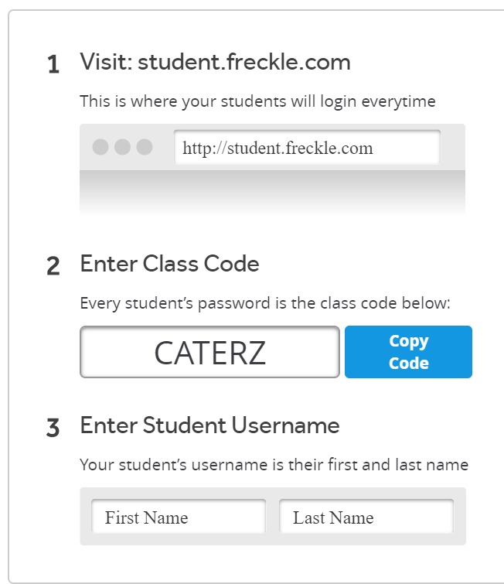

If you have ANY questions, please reach out to me via e-mail or on Class Dojo. My office hours are between 9 and 10:30 each day. If you write to me outside of those hours, please allow
24 hours for a response. I will check messages several times during the day.

Please take care and let me know if you need ANYTHING! 😊

Eileen Cater
Eileen.cater@cobbk12.org

