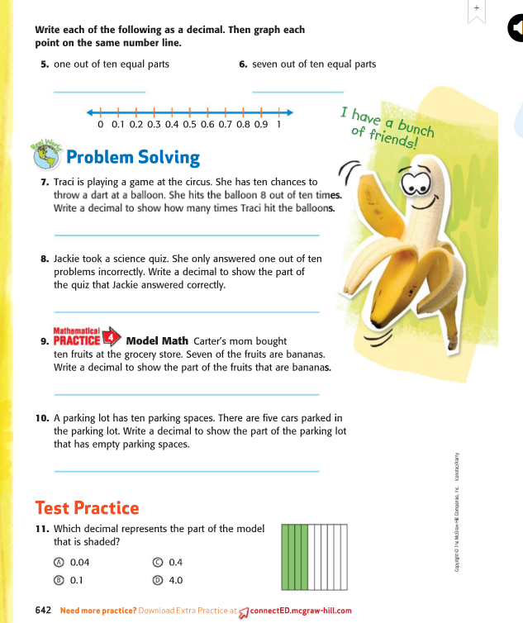 | 5)When talking decimals let us think money. So there are 10 dimes in a dollar. That is represented as .10  6) 7 = .70  10  On the number line you see 0.1 0.2 0.3  Same as 0.10 0.20 0.30  Same as .10 .20 .30  7) If she has 10 chances that is the denominator. She hits 8 out of 10  So that is 8 or 0.8 same as .8 same as 0.80  10  8) There are 10 problems. She answered 1 incorrectly, so she answered 9 correctly.  She answered 9 or .9 same as 0.9 same as 0.90  10  9) answer .70  banana banana banana banana  banana banana banana  10) .50 are empty  car car car car car  11) C

